Canada Is Really Big! Population Growth, the Housing Crisis, and Information Technology
By Cole Cioran

Introduction
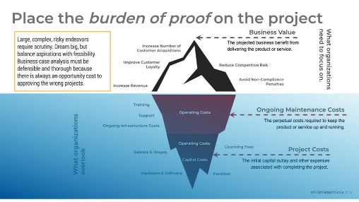
It goes without saying that Canada is REALLY BIG. There’s even a song about it! We also passed the 40 million people milestone last month, and the recurring theme that has come with it is that we’re bursting at the seams. Homelessness, the housing crunch, asylum seekers sleeping in the streets, pressure to accelerate permitting and support immigration, and other challenges are symptoms of real problems that IT must help resolve by delivering exponential returns on investments in technology and digital services. Nowhere is this more apparent than in the front-page news related to the housing crisis. For example, Ben Rabidoux of Edge Realty Analytics recently identified that there has been a rapid decline in single family unit permit requests at the same time population growth has spiked. Single family homes are not the only solution, of course, and there are innovative solutions being proposed. Developers are seeking approval to transform underused mall space to residential hubs which would both drive housing and reinvigorate currently underperforming retail space. The City of Victoria has an ambitious, if struggling, strategy to build more “missing middle” housing. The critical step in getting these projects off the ground is permitting approvals. The average approval time is 249 days for Toronto, a key growth centre, and provincial permitting wait times can be measured in years. Process ownership might be outside of IT, but technology has material contributions to make both directly and indirectly to acceleration, including:
Seven Steps to Accelerate Building Permits in Canadian Municipalities
CIO Roundtable: Fighting the housing crisis: How to accelerate building permits
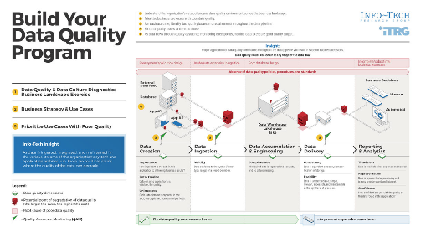
- Modernizing permitting platforms so they are ready for policy changes. While changes to the platform will make for incremental improvement in processing times, an out-of-date platform can be a massive roadblock to implementing new policies. Even further, modernization can also be used as a catalyst process and even policy change. Municipal budget season is upon us, and responsible IT leaders should be making the case for investment to replace legacy CXM and permitting platforms.
Build a Comprehensive Business Case
- Enabling virtual and asynchronous community consultation to reduce delays caused by scheduling meeting. One of the biggest delays in permitting is community consultations, and having robust software for internal collaboration became a necessity during the pandemic. However, not all municipalities have embraced it for community consultation, and selecting a platform that supports both internal and external use cases is critical.
Build Your Data Quality Program
- Ensuring the highest quality of data for planning and permitting to reduce rework and accelerate decisions. It is the key to unlocking the existing and upcoming funding available from Infrastructure Canada for the National Housing Strategy for homes, process improvements, and tackling homelessness. The kind of changes we need to make will require significant investments.

Building the Workforce to Build the Homes

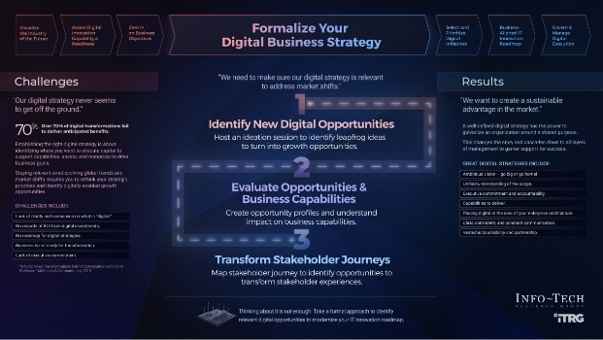
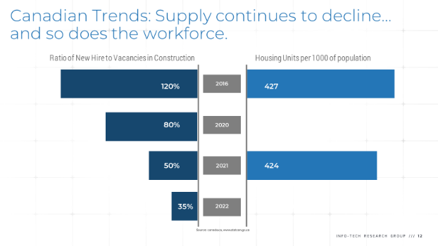
Permitting will not be enough, however. Our research shows there has been a rapid decline in the supply of new hires and available units per capita across Canada. This paints a clear picture of the need for a vast influx of labour into the building industry. The population is growing, but it is clear we need to be more targeted and focus education, training, and immigration targets on this critical sector. Despite our rapid growth, immigration backlogs also continue to grow. A good example is citizenship ceremonies. There is currently a backlog of 308,000 citizenship applications and an average wait time of 19 months. The federal government has proposed a “Citizenship on a Click” regulatory amendment proposal to help cut the backlog. However, the proposed changes for Digital Attestation have been the target of protest. From our perspective, this is symptomatic of a fundamental challenge faced by digital government initiatives in Canada. Digital services have the power to provide exponential returns and efficiency for government. They will also face opposition because they are such a radical departure from traditional, face-to-face service delivery. Unlike commercial services, digital government services will always face the risk of being politicized. Effective digital strategies for government require much more than good design and implementation; they require thoughtful change management, proactive assessment, and communications planning that prevents the change from being used against the government.
Formalize Your Digital Business Strategy

Our Take
Modern platforms, reimagined processes, and robust digital strategies are all spokes in the wheel IT leaders can use to get our support for Canada’s burgeoning population rolling and resolve the housing crisis. However, these spokes need a hub around which to rotate, and that hub is data quality. Good data is not just for internal decision making. It is the key to unlocking the existing and upcoming funding available from Infrastructure Canada for the National Housing Strategy for homes, process improvements, and tackling homelessness. The kind of changes we need to make will require significant investments. Reducing the time to funding for national programs requires timely, high-quality data such as clear and compelling narratives for your initiatives, accurate location data, and costing, all of which are key to accelerating approvals. In addition, clear, concise reports on outcomes from that investment are also critical as they drive future investment.

Want to Know More?
Click any of the links below to book a call on the topic and get ready to enhance your enterprise portfolio management practices or see these supporting blueprints!

CIO Roundtable: Fighting the housing crisis: How to accelerate building permits
Seven Steps to Accelerate Building Permits in Canadian Municipalities
Build a Comprehensive Business Case
Build Your Data Quality Program
Formalize Your Digital Business Strategy

