Preparing for Ontario’s Provincially Mandated Municipal Maturity Assessment
By Jim Kirk
As a company founded and headquartered in Ontario, Info-Tech has been closely monitoring the developments around the Hazel McCallion Act and the decision to dissolve Peel Region. Beyond the near-term implications for Mississauga, Brampton, and Caledon, the province has also announced that regional facilitators will be named to assess the upper-tier municipalities of Durham, Halton, Niagara, Simcoe, Waterloo, and York.
There appear to be two primary objectives with these assessments: To determine the effectiveness of the upper-tier municipalities at meeting the needs of the communities they serve and to assess the maturity of the lower-tier municipalities to see if any might be well positioned to pursue dissolution. In short: municipal maturity assessments.
For those municipalities who will be engaged by facilitators soon, we recommend the following readiness activities:
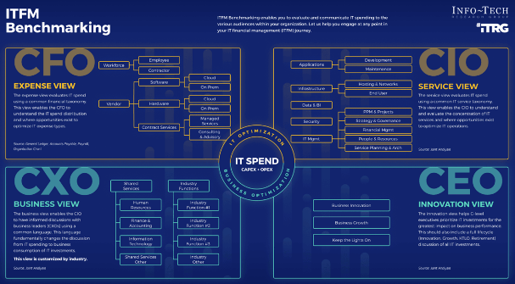
- Assess your process maturity, staffing, and spending using Info-Tech’s objective frameworks and methods.
Our IT Management & Governance diagnostic is based on COBIT and allows you to quickly assess the perceived importance and effectiveness of your core IT processes. It helps you clarify process ownership in your organization and prioritize process improvement.
The IT Staffing Assessment diagnostic is an effective time study for IT. It helps you justify existing or additional headcount, demonstrate the correlation between staffing levels and customer satisfaction, and allocate your staff more effectively (across functions and low- and high-value activities).
Our IT Spend & Staffing Transparency research provides a proven model to both map and visualize your organization’s true IT spend. It provides several views that will resonate with your entire C-suite.
If you’d like our experts to do more of the heavy lifting in modeling your spend and staffing data in this way, you can consider our IT Spend & Staffing Benchmarking Service. Members with an available workshop credit can choose to apply it to use this service.
- Validate your IT service management fundamentals to ensure you can effectively deliver services to lower-tier municipalities. These same fundamentals can aid in your ability to manage the performance of those delivering services to you.
Do you have a service catalog today? Is it a living document that is up to date? In speaking with members about the importance of a service catalog, I like to ask if they’ve ever walked into a restaurant where there was no menu. It’s foundational in describing the value you offer in a way that your customer can understand, appreciate, and take action on.
If your catalog is in place, what about a service-level agreement framework? Success at either end of a shared services relationship is predicated on a clear understanding of what’s being delivered, who’s doing what, and what level of performance can be expected. And what about service costing? Without a clear and defensible cost model, you may not recover the funds you need to deliver the service.
Lastly, you can’t manage what you don’t measure. Ensure you have a service performance measurement capability and have developed service metrics that are meaningful and articulate the value your service offers your customer.
- Evaluate your application and project portfolios. Applications play a critical role in enabling the vision and customer experience that is outlined in a digital strategy. It’s imperative you can demonstrate that your applications are delivering value to the organization. Application portfolio management best practices will help you create or refresh your application and platform inventory, assess your current state (including customer satisfaction, technical health, and total cost of ownership), and clarify your short- and long-term goals. 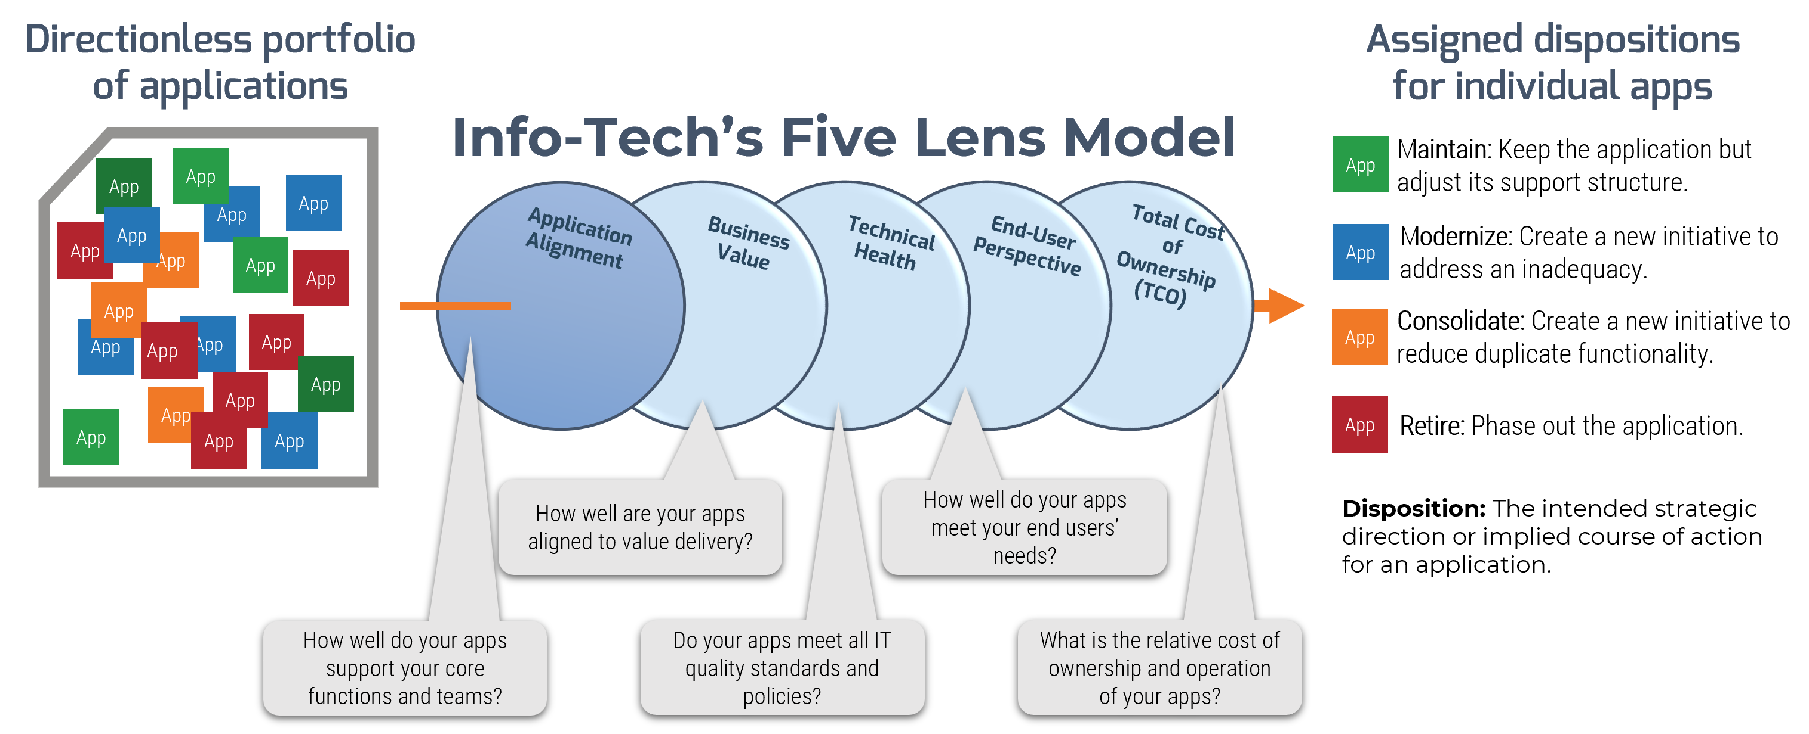
The project portfolio is a critical component of how IT helps the organization achieve strategic objectives. In any maturity assessment, it’s likely that a review of the current project portfolio and practices is likely. If you can’t effectively manage a portfolio of projects for your organization, how can you do the same in support of service delivery to another? Info-Tech’s project portfolio audit framework will help you perform a high-level triage of your portfolios, projects, and supporting practices.
Members with access to our concierge services can use our Project Backlog Rationalization Service. Our analysts will help you assess the root causes of any disorder in your project intake and backlog management practices and help you get a clear understanding of where your delivery capacity is being spent.

Our Take
To our Ontario municipal government members, don’t wait for the regional facilitator to knock on your door. Take charge of the process and be prepared for the assessment. In circumstances like these, it is in your best interest to leverage objective, third-party frameworks to assess your current state and measure the effectiveness of your delivery. Fortune will always favor the prepared.
Following the assessments and resulting reports and recommendations, Info-Tech will be ready to help you take your due diligence and planning to the next level of detail and support any organizational or service changes required to meet a new or changed mandate.

Want to Know More?
Click any of the links above to book a call on the supporting topic and prepare for your municipal maturity assessment.

