Business as Unusual: Successfully Coping With the IT Impacts of the 2023 Canadian Federal Government Strike

The Canadian federal government is managing its first significant strike in decades. How can GC IT agencies and departments manage this event and be successful?

Authors
Matt Bourne, Paul Chernousov, Patrick Spencer
Introduction
On Tuesday, April 19, many Canadian federal government employees went on strike. Talks are currently underway, and two main groups are involved: approximately 120,000 workers under the Treasury Board Secretariat (TBS) and 35,000 workers employed with Canada Revenue Agency (CRA). This work stoppage is occurring primarily due to employee grievances and as with all strikes is intended to draw attention to desired concessions. Notably, this work stoppage is occurring after the completion of FY22 fiscal before many departmental activities ramp up for FY23. Regardless, after a long pandemic and lengthy work-from-home period, it is yet another challenge for federal workers. However, with challenges come opportunities.
It is important to be aware of the potential backlog, intake, constant shifts in demand, resource constraints, and remote work challenges that may arise. IT teams should be prepared to adapt and adjust their processes to mitigate the impact of the strike as much as possible. The last federal strike of this magnitude occurred in the 1990s, and since that time the IT technology, management, and leadership landscapes have completely changed. As a result of ongoing efforts to accelerate Canada’s Digital Ambition, the role of IT across the Government of Canada is more central than it has ever been.
Below is initial guidance to support leaders as they navigate this event. We shall provide additional insights and guidance as this event unfolds.

We’ve Been Here Before
Strikes have impacted other governments. Below are some notable examples.
UK Public Sector Pension Strike: In 2018, a public sector pension strike in the UK impacted various government services, including IT operations. The strike resulted in reduced staffing levels and delays in processing IT-related requests and issues. This highlighted the need for contingency plans and clear communication with stakeholders to manage expectations and address any concerns or issues that arose during the strike.
French Transportation Strike: In 2019, a transportation strike in France disrupted various public services, including IT operations. The strike impacted the ability of IT staff to commute to work, resulting in reduced staffing levels and delays in responding to IT-related issues. This highlighted the need for flexible work arrangements and contingency plans to ensure that critical IT systems and services remained operational.
US Government Shutdown: In 2019, a US government shutdown lasted for 35 days, impacting various government services, including IT operations. The shutdown resulted in reduced staffing levels and delays in processing IT-related requests and issues. This highlighted the need for contingency plans and prioritization of critical IT systems and services during periods of reduced staffing
In each of these cases, the government took proactive steps to manage the impact of the strike on IT operations. This included contracting external IT support, adjusting priorities, and communicating with stakeholders to address any concerns or issues that arose during the strike.
Leadership, Leadership, Leadership
Government leadership plays a critical role in supporting IT and helping to mitigate the impact of the strike on IT operations. Government leadership can support IT by providing clear guidance, allocating resources, communicating regularly, offering flexibility, and fostering collaboration. By working together, IT and government leadership can help minimize the impact of the strike on critical systems and services and ensure that the organization can continue to function as smoothly as possible. Providing clear guidance, allocating resources, communicating regularly, and offering flexibility are key management attributes that matter throughout this event.

Assessing Severity of Impact
A strike can have significant impacts on IT, and these impacts increase the longer it lasts. IT will need to be proactive and adaptive in its approach to managing its operations, adjusting its priorities and workflows to ensure that critical systems and services remain operational and that any impacts on service levels are minimized. Some high-level observations are as follows:
Short strike (2 weeks or less):
- Minimal impact on IT operations, as many critical systems and services may still be operational.
- Some delays or backlogs may occur, but IT can likely manage the workload without significant disruption.
- IT may need to reallocate resources or adjust priorities to manage any impacts on service levels.
Medium-length strike (1-3 months):
- IT operations may start to feel the strain, with increased backlogs and delays.
- IT may need to adjust its workflows and processes to manage the workload effectively under reduced staffing levels.
- IT may need to prioritize critical systems and services and delay or postpone non-essential projects.
Longer strike (more than 3 months):
- IT operations may be significantly impacted, with extensive backlogs and delays.
- Critical systems and services may be at risk of disruption or failure due to reduced staffing levels and increased workload.
- IT may need to suspend or delay non-essential operations and prioritize the most-critical systems and services.
- IT may need to consider outsourcing or contracting additional resources to manage the workload.

A Key Consideration: Contact Centre Service Experience Impacts
This strike can have a significant impact on government contact centres responsible for handling inquiries, complaints, and other interactions with the public. It's important for organizations to have contingency plans in place to manage the potential impacts on staffing levels, services, and customer satisfaction. Contact centre managers should be prepared to adapt to changing circumstances and communicate proactively with staff and callers to minimize the impact of the strike, and IT should be prepared to support those managers. Potential impacts include:
Reduced staffing: Reduced staffing levels in government contact centres, resulting in longer wait times for callers and a higher likelihood of calls being dropped or unanswered.
Backlogs: Contact centres may struggle to keep up with the volume of calls and inquiries due to reduced staffing levels, leading to unresolved issues to be addressed once the strike is over.
Reduced services: Some services will be suspended or reduced during a strike, affecting the types of inquiries and requests received by contact centres.
Increased pressure: Contact centre staff are likely to face increased pressure and stress due to higher call volumes and longer wait times. This can lead to reduced job satisfaction and burnout.
Inconsistent messaging: With reduced staffing and potential changes to services, maintaining consistent messaging across contact centre interactions will be a challenge. This can lead to confusion among callers and potentially negative customer (and employee) experience.
Managing in a Hybrid Environment
Enshrining hybrid work in agreements is one of the items outlined by striking parties. Somewhat ironically, hybrid work is also an ongoing aspect that IT leaders across the Government of Canada’s departments and agencies are using during the strike to ensure worker engagement, satisfaction, and continuity of service delivery. Indeed, reinforcing resilient workforce behaviour will be a differentiator for your department and agency.
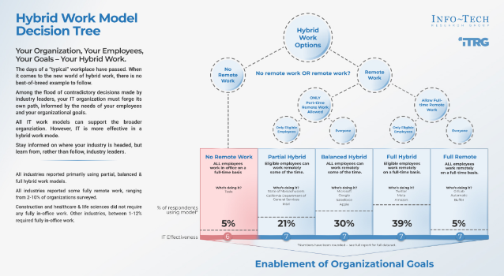
Info-Tech has conducted significant research in this fast-developing trend post-pandemic. Please refer to our State of Hybrid Work in IT blueprint. For additional support, please see the extensive resources provided in our Hybrid Workplace Research Center.

Consistent, Effective Communication
Is Key
Effective communication is critical during a crisis, both within IT and with other departments and stakeholders. Effective crisis management has a long-term demonstrable impact on your organization, long after the crisis is resolved. IT needs to be transparent about the impact of the strike on its operations and any changes to service levels or support. Consistency in messaging and in format is also recommended. IT should also maintain regular communication with key stakeholders to provide regular updates and address any concerns or issues that arise.
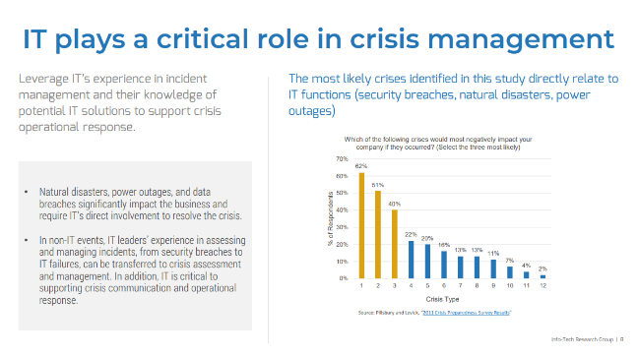
Info-Tech can support your efforts here with practical frameworks including our Implement Crisis Management Best Practices blueprint and specialized templates ranging such as our Crisis Communication Guides.

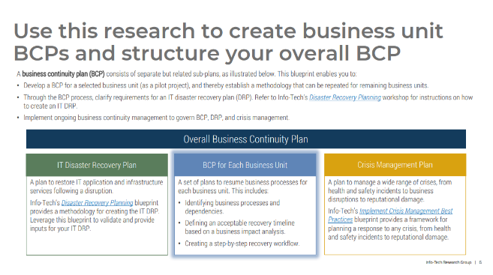
Understanding Impacts to IT Operations
As we move through a work stoppage with an unknown completion date, continuity of IT services and support needs to be a key consideration for Government of Canada department leaders. Info-Tech recommends leaders revisit their business continuity plans (BCPs) so that teams execute a plan to “keep the lights on” wherever possible. Please see Info-Tech’s practical research Develop a Business Continuity Plan for further details.

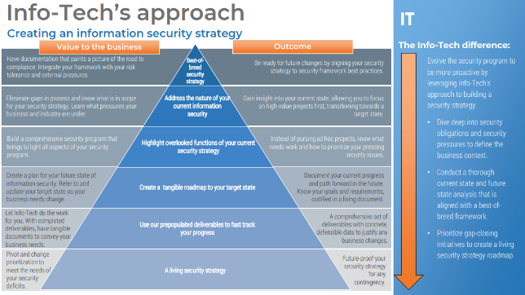
Cybersecurity Considerations
The strike could potentially increase cybersecurity vulnerabilities by causing understaffing, reducing coordination, increasing insider threats, hindering security incident response, and creating distractions that could be exploited by rogue actors including cybercriminals and other hostile actors. The federal government has been investing heavily in cyber resiliency; please see our tech note Budget 2022: Support for Canadian Federal Departments and Agencies for Cybersecurity and Fighting Misinformation. It is important for government departments and agencies to prepare contingency plans to mitigate these risks and ensure that their cybersecurity posture remains strong during times of labour unrest. Please see Info-Tech’s Build an Information Security Strategy blueprint.
Resource Management Considerations
IT needs to manage its resources effectively during a strike to ensure that critical tasks are prioritized and completed on time. Agility is a virtue that departments and agencies need to embrace. This may involve reallocating resources to ensure that essential IT operations are supported and any backlogs are addressed as quickly as possible. Info-Tech’s IT resource management practices playbook and templates are practical tools to support managing resources. The business will likely adjust its project intake, approval and prioritization activities, and IT teams will also adjust backlog items timelines to account for reduced staffing levels or changes in demand.

A Checklist for Success
Below is a simple checklist that leaders can follow to manage day-to-day efforts.
- Prioritize critical systems and services: Identify the critical IT systems and services that need to remain operational during the strike. Assign resources and prioritize workloads accordingly to ensure that critical systems and services are not impacted.
- Execute contingency plans: Develop contingency plans to address any staffing shortages or issues that may arise during the strike. This may include contracting external IT support or cross-training existing staff to handle additional responsibilities.
- Communicate with stakeholders: Establish clear communication channels with stakeholders to manage expectations and address any concerns or issues that arise during the strike. This may include providing regular updates on IT operations and service levels.
- Implement flexible work arrangements, as required: Consider implementing flexible work arrangements, such as remote work or adjusted schedules, to ensure that IT staff can continue to support critical systems and services during the strike.
- Monitor and report on IT operations: Monitor IT operations closely and report any issues or concerns to senior management. This will help ensure that any problems are addressed quickly and efficiently.
- Ensure compliance with legal requirements: Ensure that IT operations remain in compliance with any legal requirements during the strike. This may include data privacy and security regulations as well as labour laws and regulations.
- Establish a triage process: If IT operations are impacted during the strike, establish a triage process to prioritize issues and ensure that critical systems and services receive immediate attention. This will help minimize the impact of the strike on the organization and ensure that critical business functions continue to operate.
- Maintain regular communication with IT staff: Keep in regular contact with IT staff to understand their needs and concerns during the strike. This will help ensure that IT staff remain engaged and motivated during this challenging period.
- Document all IT-related issues: Document all IT-related issues that arise during the strike, including the steps taken to resolve them. This will help identify areas for improvement and inform the development of future contingency plans.
- Evaluate the impact of the strike: Once the strike has ended, evaluate the impact on IT operations and identify any areas for improvement. Use this information to update contingency plans and improve IT operations going forward.

Our Take
Managing the current Canadian federal government strike requires leadership, communication, transparency, and flexibility. By adopting the tactics outlined above and remaining resilient, leaders across Canadian government departments and agencies will be able to mitigate many of the negative impacts of this strike.
Want to Know More?
Please reach out to your Info-Tech Research Group Account or Executive Services representative today. You may also click the link in any of the links above to schedule an analyst call.

