Support Mental Wellbeing During COVID-19 Webinar FAQ

For more information, visit McLean & Company’s COVID-19 Resource Center and book a call with one of our analysts.

McLean & Company Phone Numbers:
- Toll-Free: 1-877-281-0480
- International: +1-519-936-2659

Question | Answer
At a time when budgets are tight for many organizations, what are some ways to support employees if an EAP doesn’t already exist and is not feasible? | If ever there was a time to make the case for an EAP, it’s now! They also are relatively a relatively small expense as far as budgets go. However, if there really isn’t room in the budget for one, there are many other supports that can be leveraged. Wellness training and specialized webinars are great to get the ball rolling, but you’ll want to ensure that more individualized and timely supports are also available. Benefits are another great place to add value and you’ll want to ensure that the coverage provided for wellbeing professionals is sufficient. Finally, check your jurisdiction for free resources and relevant helplines to leverage. Many organizations are providing free mental health resources to the public (e.g. CAMH in Canada). Create a list of these and clearly communicate them and encourage their use to all employees.
What do you do if you’ve provided an employee with all the supports you can, but their performance is still suffering due to burnout and stress? | Unfortunately, there is only so much help you can provide to an employee. Their wellbeing is ultimately their responsibility, but there may be underlying factors compounding their stress and burnout that can still be addressed. If adjustments have not yet been made to their hours or if time-off (paid or unpaid) has not been taken, look into those options. If hours are adjusted, be sure to adjust goals and expectations accordingly.  For more information about adjusting goals and expectations during the pandemic, see McLean & Company’s Performance Management for Emergency Work-From-Home.  If performance continues to suffer, it may be time to begin the performance improvement process. For more information on navigating this process remotely and addressing root causes of poor performance, see McLean & Company’s solution set Manage Poor Performance While Working From Home.
What if managers don’t have strong connections to their employees (e.g. large spans of control, not the culture, etc.)? How can they have these conversations without coming across as insincere or overbearing? | In such a critical time, manager presence is key regardless of whether they have established strong connections with their employees prior to COVID-19. No matter what old practices were, in this context, managers have to make an extra effort to be available for employees. While there is a risk of coming across as disingenuous, the best way to mitigate this is by starting a transparent dialogue about the importance of mental wellbeing. Managers can’t simply ask “how’s it going” then move on to task-related items – they need to encourage employees to reflect more deeply on how they’re doing in each aspect of wellbeing.  Start the dialogue with open acknowledgment of any span of control or culture issues and outline what your (the manager’s) involvement will be in supporting employee mental wellbeing going forward.  Serve as a role model to employees on practicing good mental wellbeing habits (taking a break, response times when employees seek help or information about supports etc.). Reinforce to employees that they are important to you by setting apart time in weekly or virtual meetings and emphasize an open-door policy (even virtually).  For more information on actions managers can take to support and engage employees through this time, see McLean & Company’s solution set Maintain Employee Engagement During the COVID-19 Pandemic.  Managers can also leverage McLean & Company’s Wellness and Working From Home infographic to start having wellness conversations.
What can HR do to protect WFH employees from risk of domestic violence? | Police are seeing a rise in domestic violence since social distancing began. Depending on your jurisdiction, HR may have policies in place that cover what to do to protect employees from domestic violence in the workplace, and these policies should be reviewed and modified to cover WFH employees. For example, the Canadian Women’s Foundation has created a one-handed Violence at Home Signal for Help sign a person can use to show they need someone to check in on them safely. Policies could be modified to instruct staff to go to HR if someone sees the hand signal, as it is important not to do anything that may make the situation worse. HR should advise on how to tackle the issue safely.  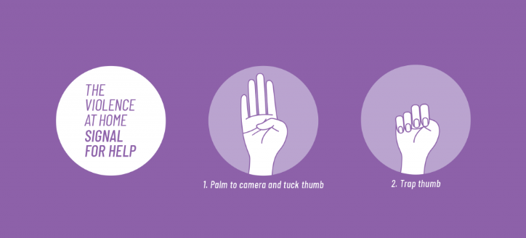  This could be a powerful message to send through the organization about caring for the wellbeing of staff and the community. For more information, see the Canadian Women Organization’s site canadianwomen.org/signal-for-help
What was the reference for research RE: intersectionality and wellbeing? | Research from Qualtrics found parents with children who are attending virtual classrooms or are new to homeschooling are almost 50% more likely to report increased anxiety and 27% more likely to report increased stress from the onset of the outbreak.
Where can I find more information on the Pandemic Pulse Check Survey? | Our Pandemic Engagement Pulse Check allows organizations to gather feedback from employees to ensure that they’re responding in a meaningful way. It has been designed to align with the main tenets outlined in the McLean & Company COVID-19 Resource Center.  For more information, you will need to contact your account representative.
Are there any specific resources for senior leaders in organizations to acknowledge the extra pressure and help them feel supported? | That is the main reason we created roundtables for our members. They are an opportunity to meet virtually with other senior HR leaders in a safe and confidential environment to talk about their fears, challenges, and opportunities at work during this pandemic. If you are interested in participating, contact your McLean representative or bmarkis@mcleanco.com. Additionally, the company EAP is a good resource as well as peer networks for the various leaders. Organize virtual meetings for senior leaders to talk only with each other.
There is a wealth of information being offered to employees, so much so that it can be overwhelming and add to the sense of stress and anxiety. What do you see employers doing to mitigate this? | Use your company intranet and have one page where links are posted for employees to access only if they want to. When informing your employees about COVID-19, restrict the information to anything that relates to their work or the company. Use a variety of communication channels (email, video, text) so as to not overwhelm employees through certain channels (typically email), which risks the message getting lost. Remind them of important government links for additional information. Again, use the opportunity to remind them of EAP resources as well.
How can managers mitigate information overload for themselves, not just for their direct reports? | Ensure senior leaders are following their own directives in terms of information sharing. Limit the information provided to managers to be only related to the organization and its employees.
What are some strategies to further embed company values to support managers as they open up communication around wellbeing with their employees? And how can this be done in a way that is supportive while still holding the individual or team accountable for their own wellbeing? | A great place to start with this is by looking at the 3i's as principles of communication (inform, interact, involve). When managers inform the team about company status or other updates related to COVID-19, link the message back to some company values. To interact with the team or individual, the manager should bring up a specific company value that is important to them and why it keeps them at the company and encourage others to share their thoughts. And finally, managers can involve the employee or team by linking the conversation to how that value supports employee wellbeing while emphasizing that individual/team performance is still expected to meet expectations for the organization to succeed.
Do we know if there's been increased usage of EAPs during COVID-19? | While we don’t have particular statistics around EAP usage, many EAPs have been developing additional COVID-19-specific resources. Anecdotal evidence from speaking with our members during roundtable sessions over the last week would support increased use.

_____________________________________________________

For acceptable use of this template, refer to McLean & Company's Terms of Use. These documents are intended to supply general information only, not specific professional, personal, legal, or accounting advice, and are not intended to be used as a substitute for any kind of professional advice. Use this document either in whole or in part as a basis and guide for document creation. To customize this document with corporate marks and titles, simply replace the McLean & Company information in the Header and Footer fields of this document.

